Exam the impact Monthly Income has on Number of Visitors per Trip and Number of Trips Taken.

Since our data false the Multivariate Normality, we have to exam the relationship between monthly income and number of visitor and number of trips separately.

Exam variable with Scatter Plots

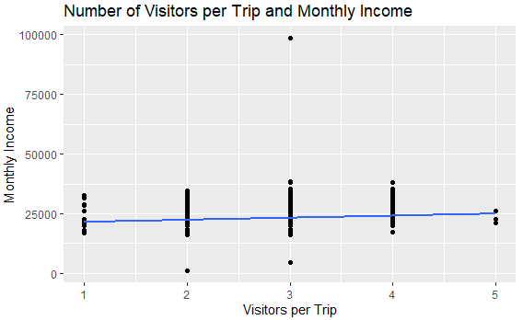

Observation:

* Although weak, income has a positive correlation with Number of Visitors per Trips.
* The majority of customers have income falling in 15,000 to 40,000.
* People of higher income takes average 3 or 4 trips.
* People who take 5 trips does not have signification different in their income.

Pearson’s product-moment correlation:

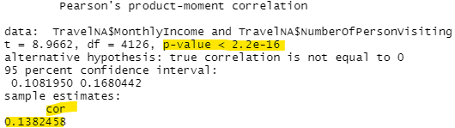

* p-value < 2.2e-16 indicate this is a significant correlation.
* r correlation coefficient is 0.1382458 indicate the correlation between Monthly Income and Visitors per Trip is a weak positive correlation.
* Our calculation result affirm our Scatter Plots

Exam variable with Scatter Plots

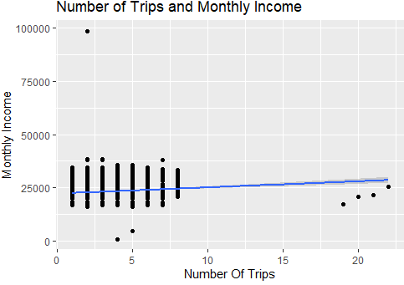

* Most people make under 10 trips total.
* People making 20 trips and above does not have signification different income.
* People with the most income does not make much trips.
* Income has very little but positive impact on number of trips taken.

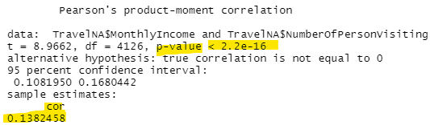

* p-value < 1.87e-14 indicate this is a significant correlation.
* r correlation coefficient is 0.1188247 indicate the correlation between
* Monthly Income and Number of Trip is a very weak positive correlation.